Weekly Report

Date__________

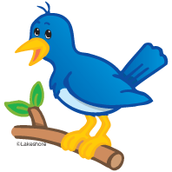

Dear_______________________,

This is how my week went in school:

**Behavior/Homework**:

|  |  |  |  |  |  |  |
| --- | --- | --- | --- | --- | --- | --- |
|  | Monday | Tuesday | Wednesday | Thursday | Friday | Participated in  Fun Friday |
| **# of**  **Warnings**  **or # of missed**  **homeworks** |  |  |  |  |  | Yes  No  Half |

0 warnings = Full Fun Friday (extra recess, games, free time, movie, etc…)

1 warning = Reminder! Fun Friday (extra recess, games, free time, movie, etc…)

2 warnings = Half of Fun Friday

3 or more = Loss of Fun Friday (phone/email/note) home

*\*\*Any severe behaviors will be sent directly to the principal and automatically out of Fun Friday.\*\**

**Academics:**

ELA (Reading): Something I learned

_______________________________________________________________________

_______________________________________________________________________

ELA (Writing): Something I learned

______________________________________________________________________________________________________________________________________________

Math: Something I learned

_____________________________________________________________________

_____________________________________________________________________

Social Studies/Science: Something I learned

____________________________________________________________________

____________________________________________________________________

**\*\*\*Parent Signature: From,**

____________________________ _____________________________